

Economics

SAC 3.1 UNIT 3 OUTCOME 1

2022
You will have 60 minutes to complete this task plus 5 minutes reading time

Teacher: Mr. Daniel Charles/Ms. Hubbard

The total SAC contributes to 40/100 of SAC marks allocated for Unit 3.

Allowed materials for this task include:
- Pens, pencils, rulers, erasers, highlighters

Name ___________________________________________

Note: The grade or score for this task is only part of the internal assessment for this Unit. Your total School-assessed Coursework score may change as a result of statistical moderation by VCAA.

Grade/Score: ______ Satisfactory Completion? S/N: ______
(Provisional)

VCE ECONOMICS
SCHOOL-ASSESSED COURSEWORK
Performance Descriptors
Unit 3  Outcome 1  Explain how markets operate to allocate resources, and discuss the effect of government intervention on market outcomes. | DESCRIPTOR: typical performance in each range
 | Very low | Low | Medium | High | Very high
 | Very limited reference to relevant theory, demonstrating a limited understanding of the operation of the market forces of demand and supply in the allocation of resources. | Limited reference to relevant theory, demonstrating some understanding of the operation of the market forces of demand and supply in the allocation of resources. | Selection of mostly relevant theory to demonstrate a satisfactory understanding of the operation of the market forces of demand and supply in the allocation of resources. | Selection of relevant theory to demonstrate a generally thorough understanding of the operation of the market forces of demand and supply in the allocation of resources. | Selection of relevant theory to demonstrate a sophisticated understanding of the operation of the market forces of demand and supply in the allocation of resources.
 | Construction and interpretation of demand and supply diagrams demonstrates a limited knowledge of how the market forces of demand and supply interact to determine equilibrium prices and quantities traded. | Construction and interpretation of demand and supply diagrams demonstrates an elementary understanding of the how the market forces of demand and supply interact to determine equilibrium prices and quantities traded. | Construction and interpretation of demand and supply diagrams demonstrates a satisfactory knowledge of how the market forces of demand and supply determine equilibrium prices and quantities traded. | Construction and interpretation of demand and supply diagrams demonstrates a generally thorough understanding of how to the market forces of demand and supply determine equilibrium prices and quantities traded. | Construction and interpretation of demand and supply diagrams demonstrates a complex understanding of how the market forces of demand and supply determine equilibrium prices and quantities traded.
 | Limited understanding of the reasons for market failure and little explanation of the effects of government intervention to address market failure. | Some understanding of the reasons for market failure, including some explanation of the effects of government intervention to address market failure. | A satisfactory understanding of the reasons for market failure, including a general explanation of the effects of government intervention to address market failure. | A generally thorough understanding of the reasons for market failure, including a sound and balanced explanation of the effects of government intervention to address market failure. | Sophisticated understanding of the reasons for market failure, including a comprehensive explanation of the effects of government intervention to address market failure.
 | Limited use and application of economics terms, concepts, theories and data in the analysis and discussion. Little use of relevant data and evidence to support explanation and discussion. | Some accurate application of knowledge and use of specialist economic terms, concepts and theories. Some reference to relevant data and evidence but not always applied appropriately. | Satisfactory selection, use and application of economics terms, concepts, theories, data and evidence to support the explanation and discussion. | Accurate definition, use and application of economics terms, concepts and theories. Sound use of relevant data and evidence to support the explanation and discussion. | Confident and accurate definition, use and application of economics terms, concepts and theories. Sophisticated use of relevant data and evidence to support the explanation and discussion.

Section A – Multiple choice questions (10 Marks)

Question 1

If a large percentage fall in a product’s price causes a relatively small percentage increase in the quantity demanded, then

A. supply is price elastic.
B. demand is price elastic.
C. supply is price inelastic.
D. demand is price inelastic.

Question 2
The diagram below shows the market for alcohol.
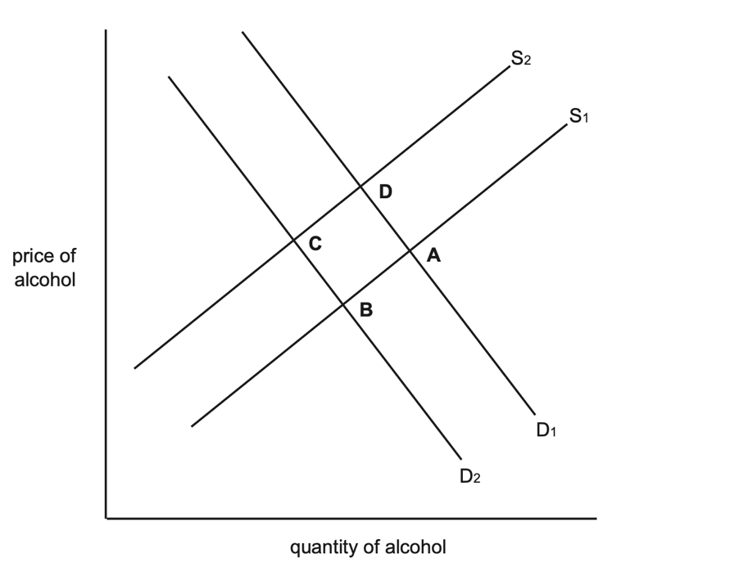
An indirect tax imposed by the government to decrease excessive alcohol consumption would result in a change in the equilibrium position from
A. C to B
B. A to D
C. C to D.
D. A to B.
Question 3

If a severe drought affected this year’s wheat harvest, what would be the effect on the equilibrium price and equilibrium quantity of wheat?

- The equilibrium price and equilibrium quantity both decrease.
- The equilibrium price and equilibrium quantity both increase.
- The equilibrium price decreases and the equilibrium quantity increases.
- The equilibrium price increases and the equilibrium quantity decreases.

Question 4

A good that is over-consumed in a free market due to being non-excludable and rivalrous would be an example of

- a public good
- a positive externality of consumption
- a negative externality of consumption
- a common access resource

Question 5

The effect of a fall in the price of a complementary Product Y on the market for Product X will be to
- shift the demand curve right, a surplus and increase the equilibrium price.
- shift the demand curve left, a shortage and decrease the equilibrium price.
- shift the demand curve left, a surplus and decrease the equilibrium price.
- shift the demand curve right, a shortage and increase the equilibrium price.

Question 6

Countries around the world have debated the introduction of a ‘sugar tax’ to combat rising rates of childhood obesity and to educate consumers about the problems associated with consuming too much sugar.
Such a tax is designed to overcome
- a lack of public goods.
- a negative externality and asymmetric information.
- a negative externality and a misuse of common access resources.
- asymmetric information and a misuse of common access resources.

Question 7
Consider and compare the following price information for beef and poultry

 | Price in year 1 (kg) | Price in Year 2 (kg)
Beef | $20 | $30
Poultry | $10 | $20

Which of the following statements is correct?
- In year 2 there was an increase in the relative price of beef
- In year 2 there was an increase in the relative price of poultry
- In year 2 there was a decrease in the relative price of beef and poultry
- In year 2 there was no change in relative price of beef and poultry

Question 8
Which of the following is not a characteristic of a perfectly competitive market?

- many sellers
- homogenous goods
- barriers to entry
- perfect information

Question 9

If a product became less popular, while at the same time increased costs of production caused the supply of the product to decrease, it can be concluded that, for this product, the
- equilibrium price might rise or fall.
- equilibrium quantity might rise or fall.
- equilibrium price and the equilibrium quantity would rise.
- equilibrium price and the equilibrium quantity would fall.

Question 10

A maximum price set below the equilibrium price in a market will cause greater shortages if
- both demand and supply are price inelastic.
- both demand and supply are price elastic.
- demand is price inelastic and supply is price elastic.
- demand is price elastic and supply is price inelastic.

Section B – Short answer questions (30 marks)

Question 1 (13 marks)
Consider the following data for apples sold in a market for a particular period of time
Price  ($ per kg) | Quantity demanded  (kg per day) | Quantity supplied  (kg per day)
2 | 12,000 | 3,000
3 | 10,000 | 5,000
4 | 8,000 | 8,000
5 | 6,000 | 9,000
6 | 4,000 | 12,000

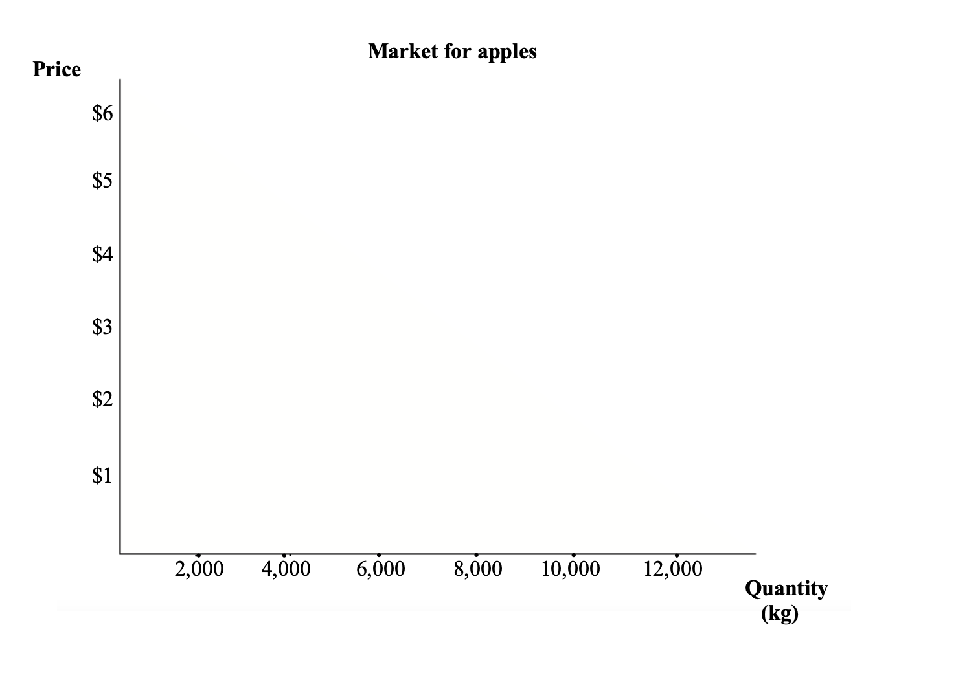
a. Construct a demand and supply diagram using the data in the table. Ensure all aspects of
the graph are labelled appropriately.
2 marks

b. Identify and explain one factor that would increase the demand for apples at every price. Draw this scenario on the graph in part 1a., clearly showing the adjustment to the market conditions.
2 marks
____________________________________________________________________________________________________________________________________________________________________
____________________________________________________________________________________________________________________________________________________________________
____________________________________________________________________________________________________________________________________________________________________
____________________________________________________________________________________________________________________________________________________________________

c. With reference to the diagram in part 1a., explain how the change in the relative price of apples led to a reallocation of society’s scarce resources.
6 marks
____________________________________________________________________________________________________________________________________________________________________
____________________________________________________________________________________________________________________________________________________________________
____________________________________________________________________________________________________________________________________________________________________
____________________________________________________________________________________________________________________________________________________________________
____________________________________________________________________________________________________________________________________________________________________
____________________________________________________________________________________________________________________________________________________________________
____________________________________________________________________________________________________________________________________________________________________
____________________________________________________________________________________________________________________________________________________________________
____________________________________________________________________________________________________________________________________________________________________
____________________________________________________________________________________________________________________________________________________________________
____________________________________________________________________________________________________________________________________________________________________
____________________________________________________________________________________________________________________________________________________________________

d. Citing two factors, explain whether the supply of apples would be considered elastic or inelastic.
3 marks
____________________________________________________________________________________________________________________________________________________________________
____________________________________________________________________________________________________________________________________________________________________
____________________________________________________________________________________________________________________________________________________________________
____________________________________________________________________________________________________________________________________________________________________
____________________________________________________________________________________________________________________________________________________________________
____________________________________________________________________________________________________________________________________________________________________

Question 2 (14 marks)
a. Outline the effect that competitive markets have on one type of economic efficiency.
2 marks
____________________________________________________________________________________________________________________________________________________________________
____________________________________________________________________________________________________________________________________________________________________
____________________________________________________________________________________________________________________________________________________________________
____________________________________________________________________________________________________________________________________________________________________

b. Distinguish the economic efficiency you used in part 2a with one other type of economic efficiency.
2 marks
____________________________________________________________________________________________________________________________________________________________________
____________________________________________________________________________________________________________________________________________________________________
____________________________________________________________________________________________________________________________________________________________________
____________________________________________________________________________________________________________________________________________________________________

c. Using an example, explain positive externalities as a reason for market failure.
4 marks
____________________________________________________________________________________________________________________________________________________________________
____________________________________________________________________________________________________________________________________________________________________
____________________________________________________________________________________________________________________________________________________________________
____________________________________________________________________________________________________________________________________________________________________
____________________________________________________________________________________________________________________________________________________________________
____________________________________________________________________________________________________________________________________________________________________
____________________________________________________________________________________________________________________________________________________________________
____________________________________________________________________________________________________________________________________________________________________

d. Using a fully labelled demand and supply diagram, explain how the Australian Government could intervene in the market mentioned in 2c to correct the market failure of positive externalities.
6 marks

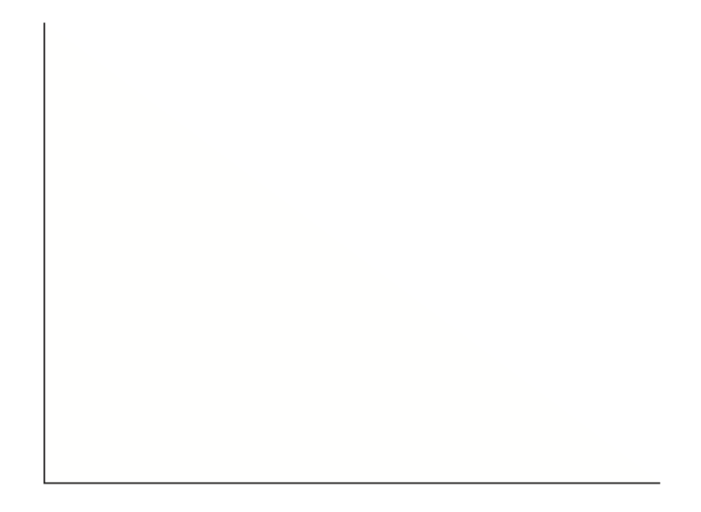
____________________________________________________________________________________________________________________________________________________________________________________________________________________________________________________________________________________________________________________________________________________________________________________________________________________________________________________________________________________________________________________________________________________________________________________________________________________________________________________________________________________________________________________________________________________________________________________________________________________________________________________________________________________________________________________________________________________________________________________________________________________________________________________________________________________________________________________________________________________________________________________________
Question 3
Identify and explain one contemporary example of government intervention in markets that unintentionally leads to a decrease in the efficiency of resource allocation.
3 marks
____________________________________________________________________________________________________________________________________________________________________
____________________________________________________________________________________________________________________________________________________________________
____________________________________________________________________________________________________________________________________________________________________
____________________________________________________________________________________________________________________________________________________________________
____________________________________________________________________________________________________________________________________________________________________
____________________________________________________________________________________________________________________________________________________________________

Extra Writing Space
____________________________________________________________________________________________________________________________________________________________________
____________________________________________________________________________________________________________________________________________________________________
____________________________________________________________________________________________________________________________________________________________________
____________________________________________________________________________________________________________________________________________________________________
____________________________________________________________________________________________________________________________________________________________________
____________________________________________________________________________________________________________________________________________________________________
____________________________________________________________________________________________________________________________________________________________________
____________________________________________________________________________________________________________________________________________________________________
____________________________________________________________________________________________________________________________________________________________________
____________________________________________________________________________________________________________________________________________________________________
____________________________________________________________________________________________________________________________________________________________________
____________________________________________________________________________________________________________________________________________________________________
____________________________________________________________________________________________________________________________________________________________________

